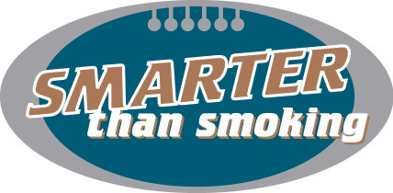

PERMISSION TO WEAR
HEAD PROTECTION DEVICE
APPLICATION FORM

Player name: League No:

Club: Team Age:

Reason: Medical Advice or Personal Division:

Team Name:

If the reason is medical, please provide Doctors report: YES / NO

If the reason is personal please provide a brief explanation for the application:

Head protection devices must be constructed of non-metallic materials.
Straps should be kept firmly to the equipment and not flailing.
The head protection device must be inspected and approved by a Junior
Competition Executive member prior to use within fixtures organised by the
Junior Competition.

Signed Parent of Guardian: Date:

Signed Player (over 16): Date:

This application for the above player to wear a head protection device was
APPROVED by:

Name: Committee Position:

Date:

Copy to be retained by the player Junior Club Registrar, the Player Team Manager
and the District Registrar.

A copy of this form needs to be produced upon request by the Field Umpire
officiating the match.

Any doctors reports should be copied and attached to all copies of this application.

WA Football Development Club File 144

